ABC’s Inventory Management System

Logout Test Scripts

Table of Contents

LOT001- Log out when logged in as warehouse staff 2

Set 1 3

Result Screenshots: 3

LOT002- Log out when logged in as store staff 5

Set 1 5

Result Screenshots: 5

# LOT001- Log out when logged in as warehouse staff

|  |  |  |  |  |  |
| --- | --- | --- | --- | --- | --- |
| **Test Name** | | Test log out when logged in as warehouse staff (Test LOT001) | | | |
| **Use Case Tested** | | Login/ Logout | | | |
| **Test Description** | | This test tests if the system logs out the warehouse staff user. | | | |
| **Pre-Conditions** | | User must be logged in as warehouse staff. | | | |
| **Post-Conditions** | | User is logged out, and the Log In page is displayed. | | | |
| **Result (Pass/Fail/Warning/ Incomplete)** | | Pass | | | |
|  | **Test Step** | | **Expected Test Results** | **P** | **F** |
| 1. | At Homepage, user clicks on ‘Logout’ icon. | | System displays a dialog box to confirm if the user wants to log out. | P |  |
| 2. | If user clicks on ‘Yes’. | | User is logged out of the system and the Login page is displayed. | P |  |
|  | If user clicks on ‘No’ | | System cancels the action and displays the homepage button. | P |  |

## Set 1

No data set is required for this test.

### Result Screenshots:

**Step 1**

Warehouse staff home page.

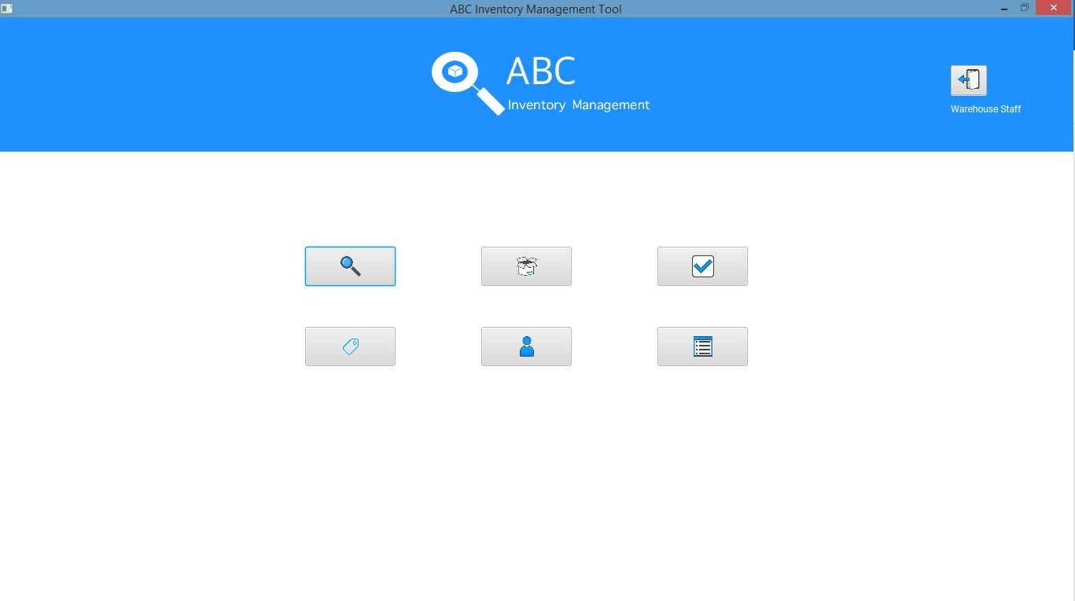

System displays a dialog box to confirm if user wants to logout.

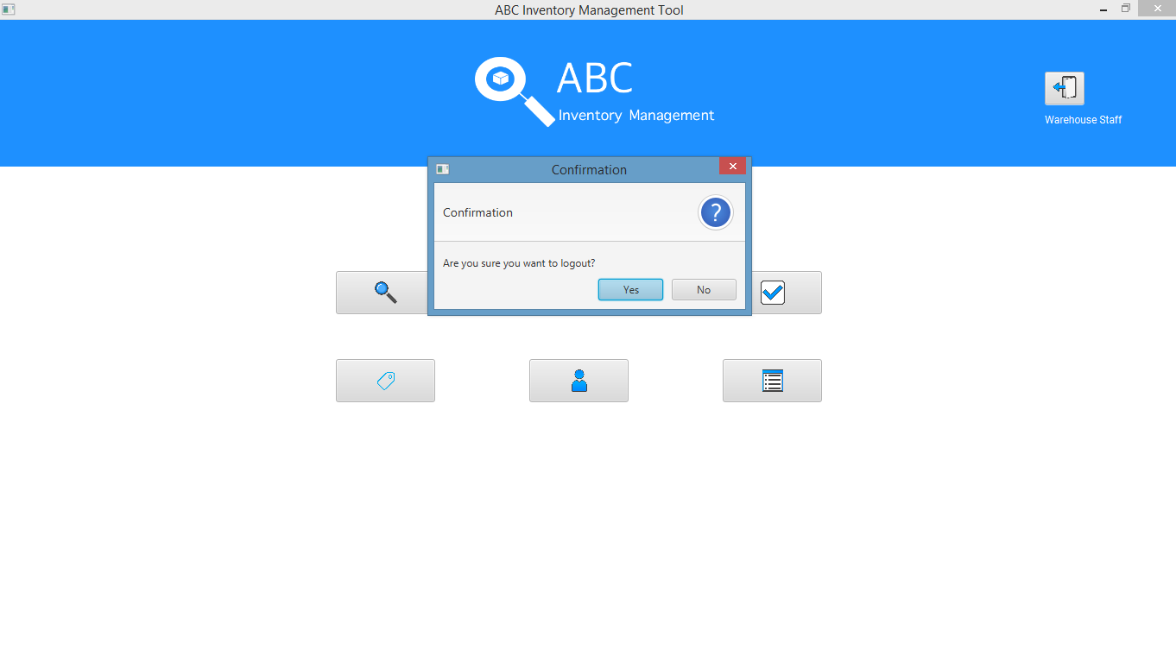

Login page is displayed after user is logged out when user clicks on ‘Yes’.

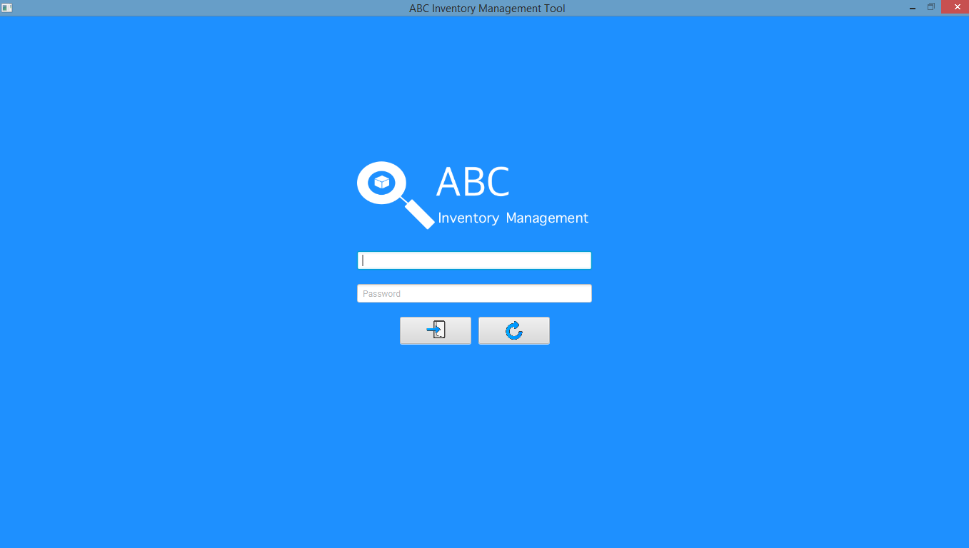

The action is cancelled, and Homepage is displayed.

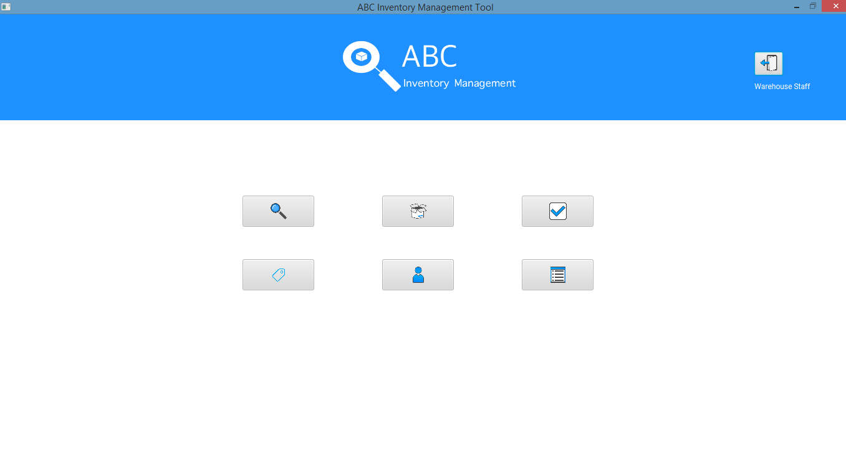

# LOT002- Log out when logged in as store staff

|  |  |  |  |  |  |
| --- | --- | --- | --- | --- | --- |
| **Test Name** | | Test log out when logged in as store staff (Test LOT002) | | | |
| **Use Case Tested** | | Login/ Logout | | | |
| **Test Description** | | This test tests if the system logs out the store staff user. | | | |
| **Pre-Conditions** | | User must be logged in as store staff. | | | |
| **Post-Conditions** | | User is logged out, and the Log In page is displayed. | | | |
| **Result (Pass/Fail/Warning/ Incomplete)** | | Pass | | | |
|  | **Test Step** | | **Expected Test Results** | **P** | **F** |
| 1. | At Homepage, user clicks on ‘Logout’ icon. | | System displays a dialog box to confirm if the user wants to log out. | P |  |
| 2. | If user clicks on ‘Yes’. | | User is logged out of the system and the Login page is displayed. | P |  |
|  | If user clicks on ‘No’ | | System cancels the action and displays the homepage button. |  |  |

## Set 1

No data set is required for this test.

### Result Screenshots:

**Step 1**

Store staff home page.

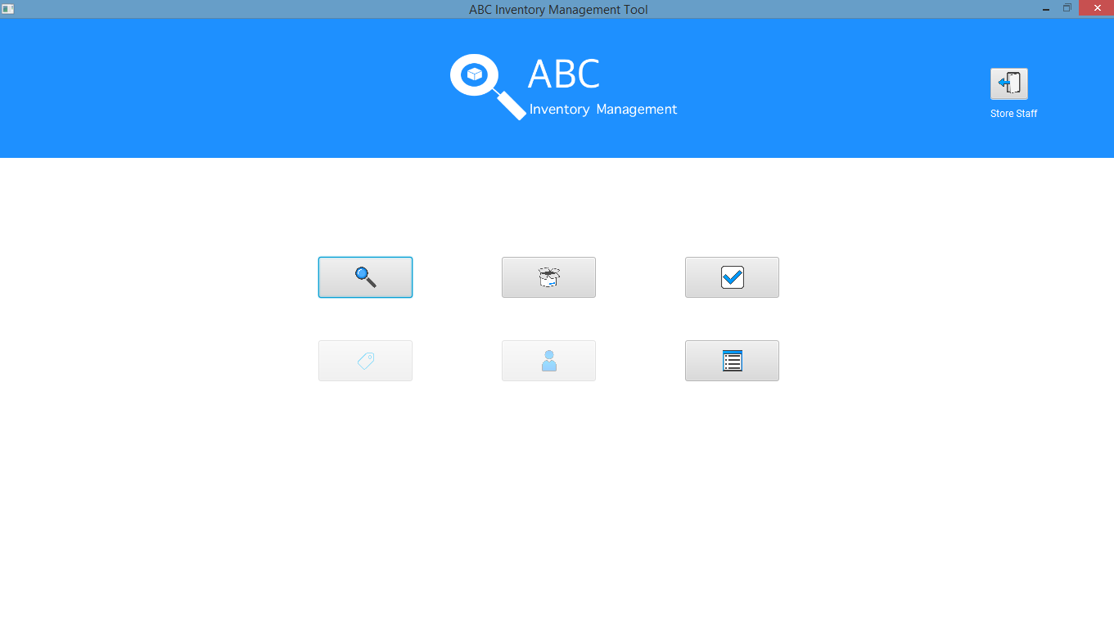

System displays a dialog box to confirm if user wants to logout.

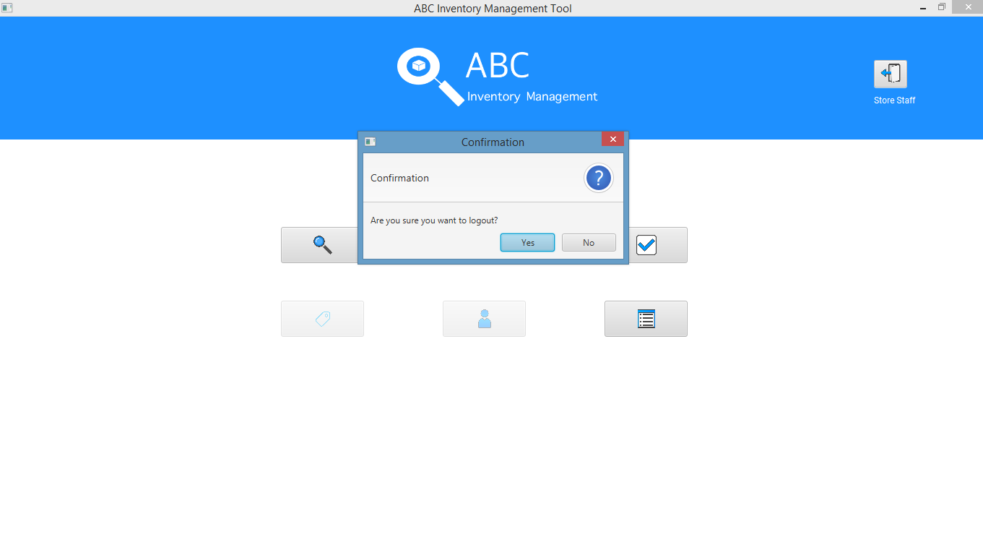

Login page is displayed after user is logged out when user clicks on ‘Yes’.

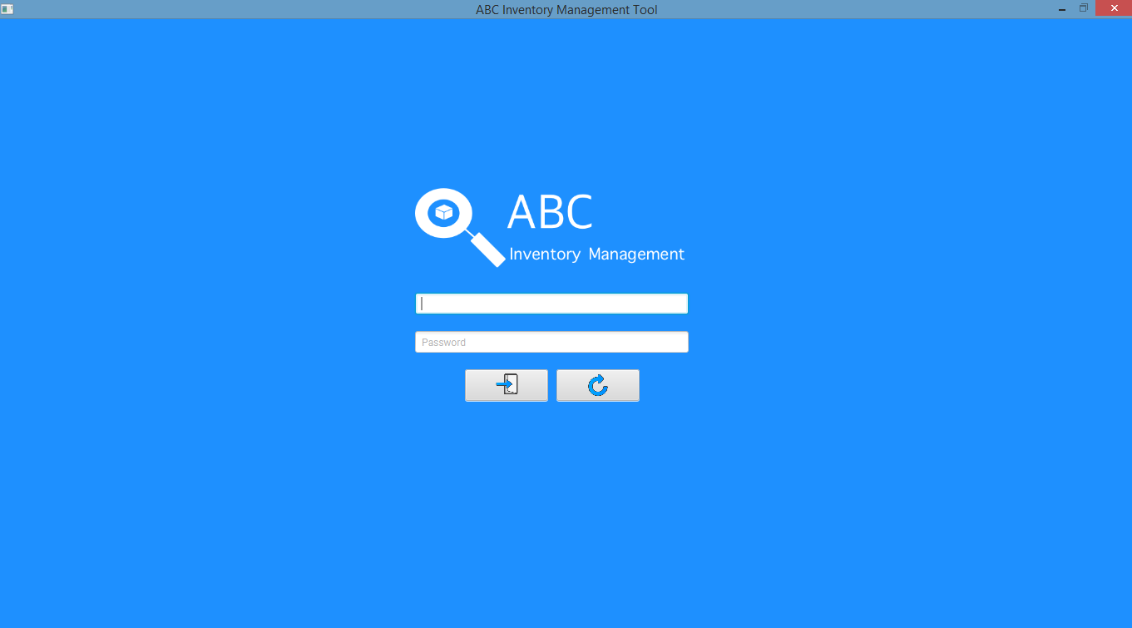

The action is cancelled, and Homepage is displayed.

